Revision History
Date | Version | Description | Author
<21/11/2019> | <1.0> | <Package Diagram,Component 1 2 3, 3.X.1 change> | <Barış Karaer>
<21/11/2019> | <1.0> | < Component 4 5 , GUI> | <Alper Sayan>
 |  |  | <Erdem Gönül>

TABLE OF CONTENTS
1 Introduction 3
1.1 References 3
1.1.1 Project References 3
2 Software Architecture overview 3
3 Software design description 3
3.1 Component 1 3
3.1.1 Component interfaces 3
3.1.2 Component design description 3
3.1.3 Workflows and algorithms 3
3.1.4 Software requirements mapping 3
3.2 Component 2 3
3.2.1 Component interfaces 3
3.2.2 Component design description 4
3.2.3 Workflows and algorithms 4
3.2.4 Software requirements mapping 4
3.3 Component 3 4
3.3.1 Component interfaces 4
3.3.2 Component design description 4
3.3.3 Workflows and algorithms 4
3.3.4 Software requirements mapping 4
4 COTS Identification 4

Introduction

This document describes the design of the HPMS software system.

References

Project References

# | Document Identifier | Document Title
[SRS] | HPMS-SRS-1 | HPMS Software Requirements Specifications

Software Architecture overview

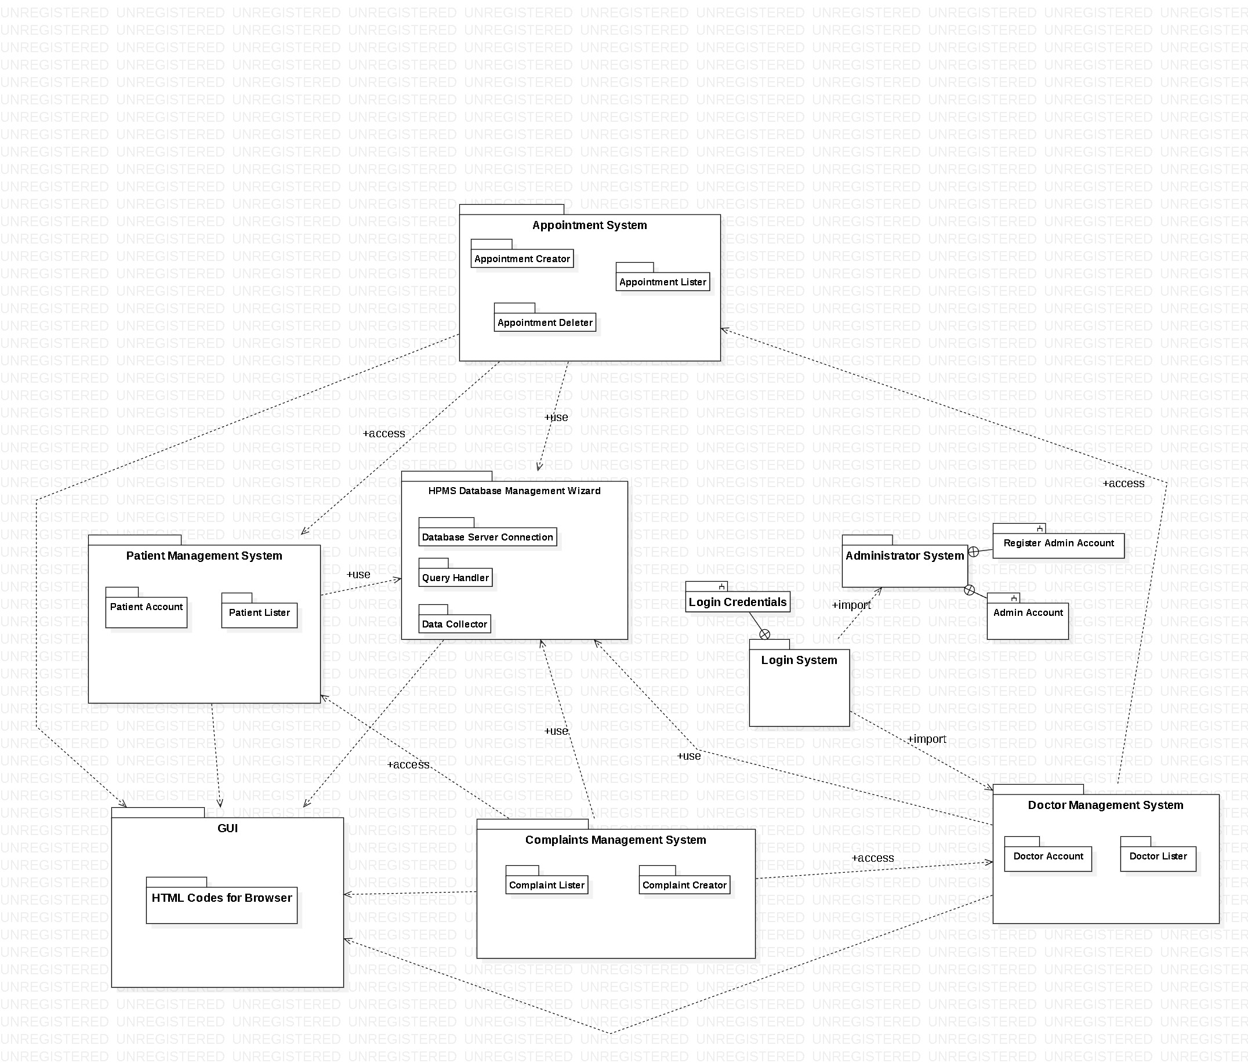

Software design description

HPMS Database Management Wizard

Component interfaces
The input data are dependent on the system that uses this HPMS Database Management Wizard. If patient management system uses this, then patient credentials will be as an input. If doctor management system uses this, then doctor credentials will be as an input. If complaint management system uses this, then inputs will be complaint information. If appointment system uses this, then appointment information’s will be as an input. The outputs might be the data that will be sent to the database. Most components of our project need the HPMS Database Management Wizard because all of our data is stored on data tables. Other components like Patient, Doctor, Complaint, Appointment Management Systems and GUI needs this database wizard to get the necessary information.

Component design description
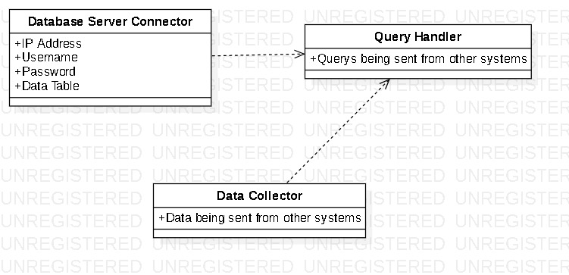

Workflows and algorithms
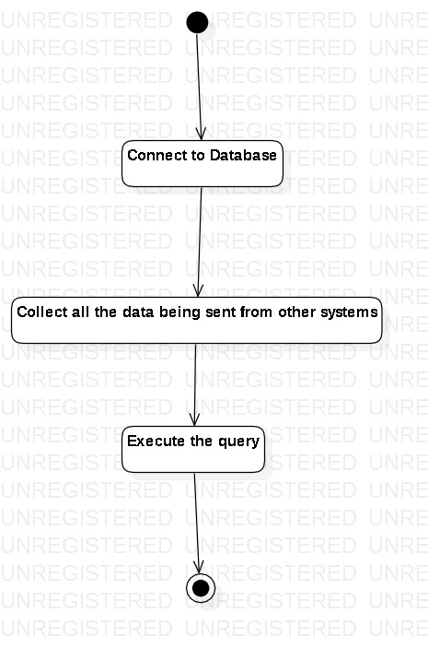

Software requirements mapping
SRS- HPMS -003.1
SRS- HPMS -006.1
SRS- HPMS -007.1
SRS- HPMS -002.1
SRS- HPMS -0010.1
SRS- HPMS -006
SRS-HPMS-003
SRS-HPMS-002
SRS-HPMS-001

Patient Management System

Component interfaces
The inputs for Patient Management System are name, surname, date of birth, blood type, address, telephone number, treatment plan, appointments, medicine problems and identity number. There are no outputs. Patient Management System communicates with database management system for the information about patients. Also complaint management systems or appointment management systems may need patient management systems for some attributes.

Component design description
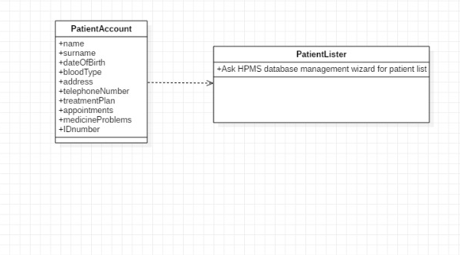

Workflows and algorithms

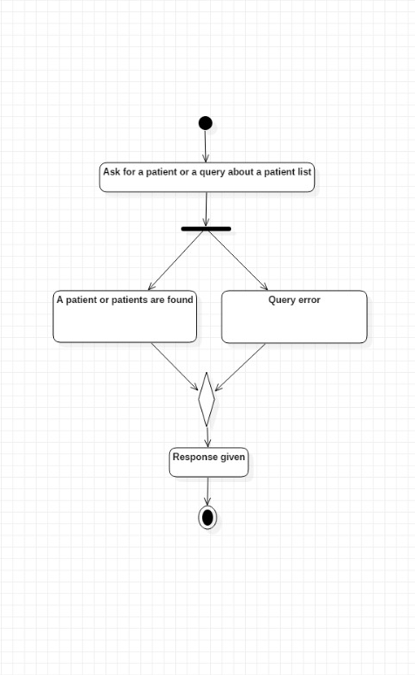

Software requirements mapping
SRS-HPMS-001.1

Doctor Management System

Component interfaces
The inputs for Doctor Management System are name, surname, date of birth, address, telephone number, patients, appointments, medicine problem replys, identity number. There are no outputs. Doctor Management System communicates with the database management system because the data of the doctors are in the data tables. Also GUI or Complaint Management System or Appointment Management System may need doctor management systems attributes.

Component design description
Doctors have attributes that was written on 3.3.1. They can be listed, be seen and be changed by an admin. Doctors can only see their own account credentials. Since patients are not an actor in our system they are only used for appointments (For doctors to see which appointment is with which patient and which appointment is at which time).

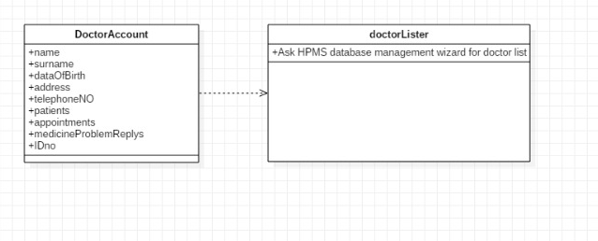

Workflows and algorithms

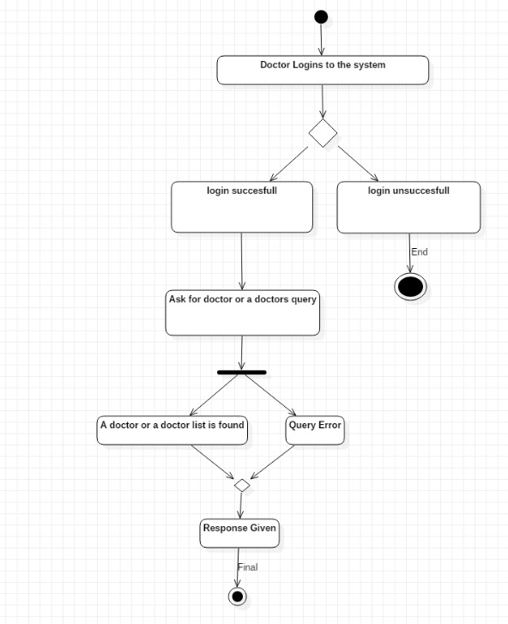

Software requirements mapping
SRS-HPMS-001.2
SRS- HPMS -009
SRS- HPMS -007

Complaints Management System

Component interfaces
The inputs for Complaints Management System are complaint messages, which patient complained, and which doctor gave a complaint message and the complaint date. There are no outputs. Complaint management system only communicates with doctor, patient and database management systems since doctor and patient information’s are needed to make a complaint.

Component design description

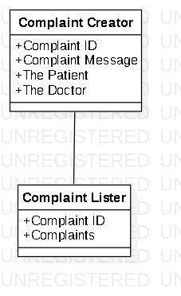

Workflows and algorithms

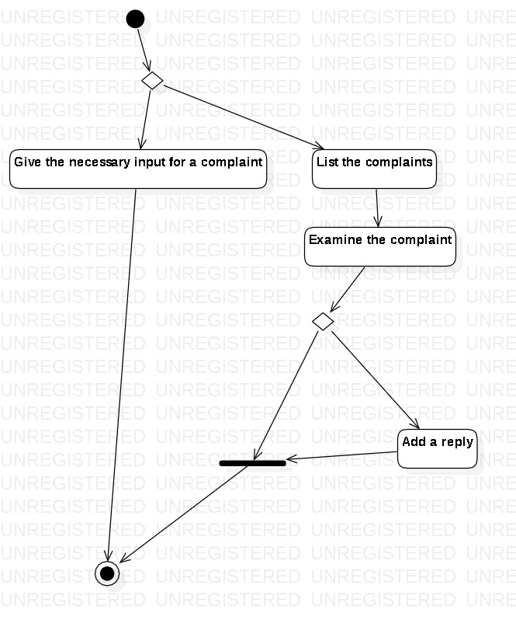

Software requirements mapping
SRS- HPMS -004

Appointment Management System

Component interfaces
The inputs for Appointment Management System are appointment date, the patient, the doctor and the treatment that is going to take place. There are no outputs. The appointment management system only communicates with patient, doctor and database management systems since the attributes for doctors and patients are needed.

Component design description

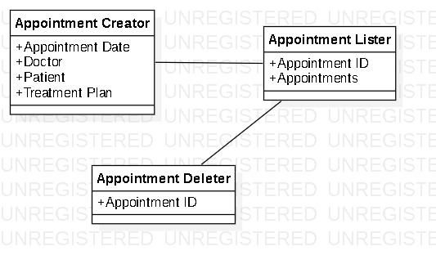

Workflows and algorithms

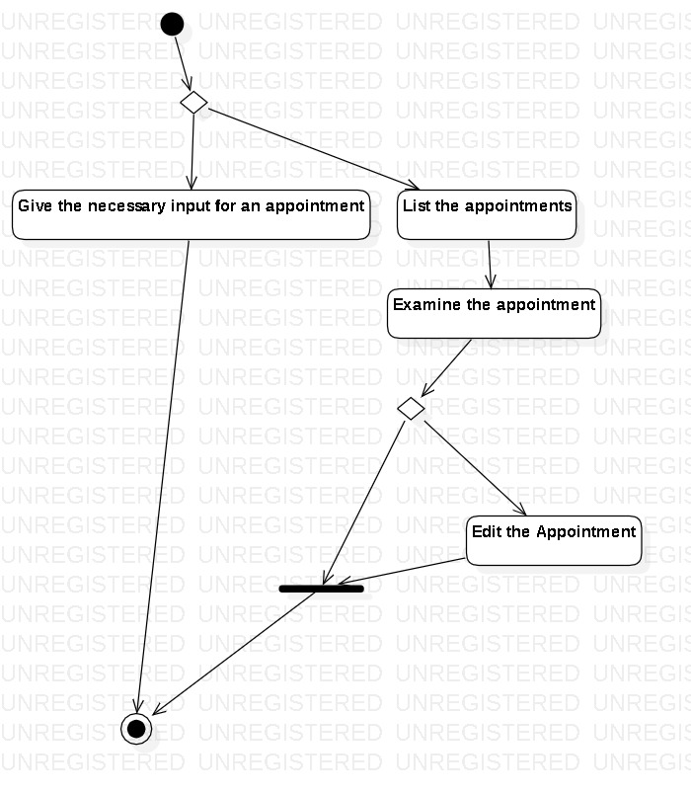

Software requirements mapping
SRS- HPMS -005

GUI

Component interfaces

The inputs for GUI are all the requested information such as patient information, appointment information, doctor information and complaint information’s. These information’s are coming from all the other associated components. GUI outputs visual are visual changes to the user and feedbacks data to the relevant components.

Component design description
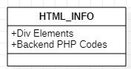

Workflows and algorithms

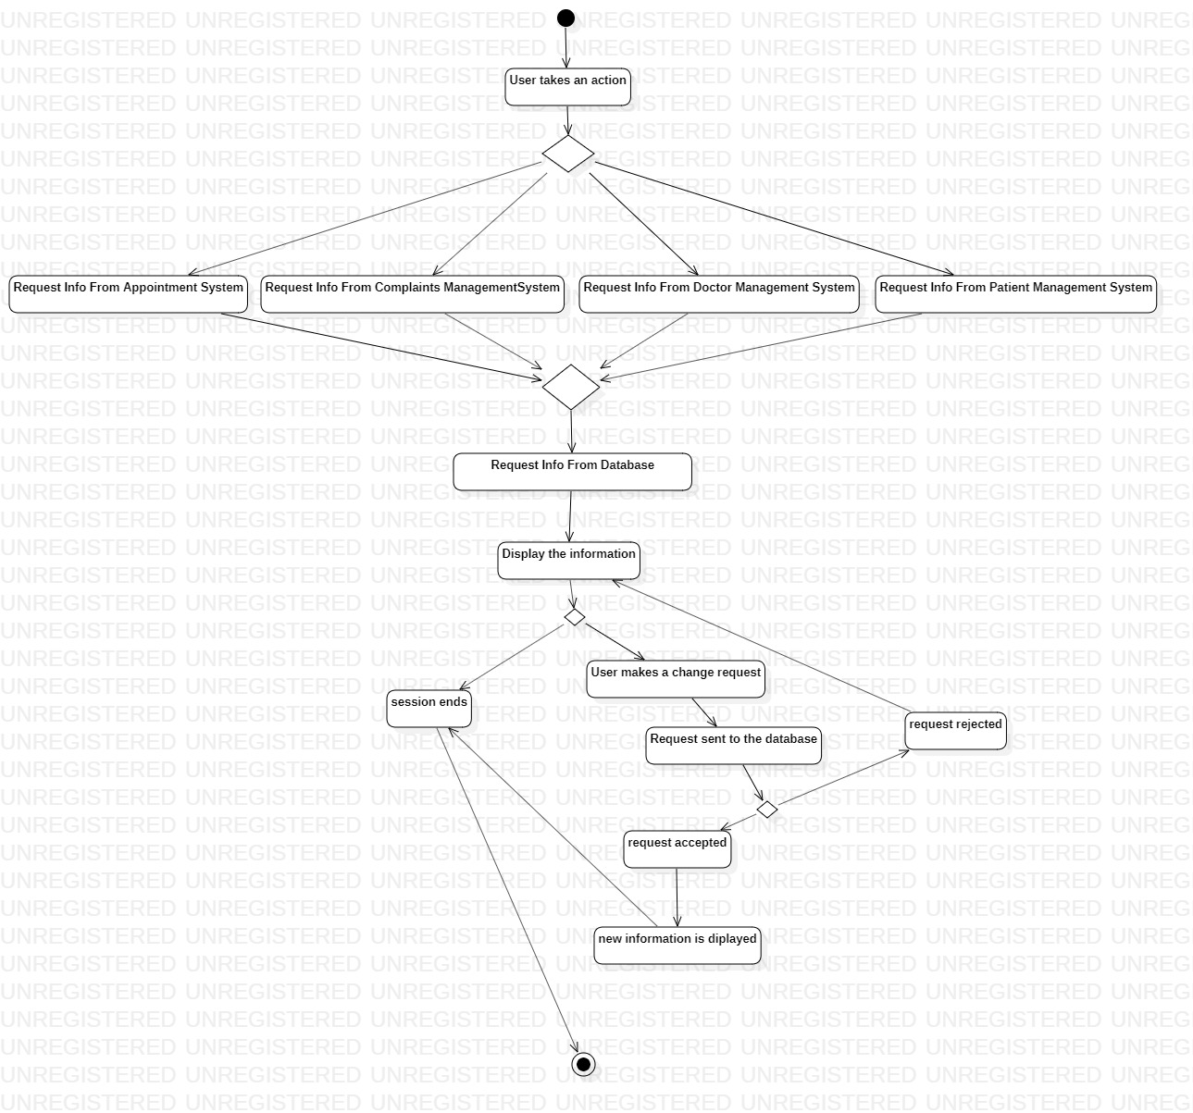

Software requirements mapping

SRS- HPMS -002
SRS- HPMS -006
SRS- HPMS -008

COTS Identification

Bootstrap 4
An Html library called Metronic Admin.

